**INTERNET PROGRAMMING LABORATORY**

Project Report

(Spring term 2022-23)

Submitted by:

Abhinav Prakash Regn no. 12216799

Surya Prakash Reddy Regn no. 12216082

Prabhat Kumar Singh Regn no. 12219419

Report belongs to Abhinav Prakash

Section KOC04 Roll no A26

Registration number 12216799

By the guidance of **SUSHIL LEKHI (28857)** Dept of CSE



Computer Science Engineering Lovely Professional University, Jalandhar December-2022

**Content**

1. Student Declaration 03
2. Introduction 04
3. Objectives 05
4. Features of the project 05
5. Screenshots of webpage 06
6. Codes 10
7. Future scope of work 27
8. Declaration 28

**1. Student Declaration**

This is to declare that this report has been written by us. No part of the report is copied from other sources. All information included from other source have been duly acknowledged. Each and every line is coded by us. We are that if any part of the report is found to be copied. We shall take full responsibility for it

………………………………..

Abhinav Prakash (12216799)

Roll no A26

………………………………..

Surya Prakash Reddy (12216082)

Roll no A15

……………………………….

Prabhat Kumar Singh (12219419)

Roll no B47

**2.Introduction**

One of the most important steps involved in creating a school web site is deciding what content will be included and how it will be organized. Building a school web site provides a unique addition to the curriculum. In the development phase, students and teachers should discuss the kinds of materials they want to add to the site.

* **School information.** General information such as the school’s telephone number and address along with driving directions should be included. Making mention of the school boundaries is also useful. The school’s history, mission statement, and awards received are interesting and serve to promote a feeling of community.
* **School policy.** The school policy is a very important document that may be made readily available by posting it on the school site. School policy information might include use of the Web in school.
* **Calendar of events.** A calendar of events provides parents, teachers and students with an easy way to keep up-to-date with the happenings at the school. Special events such as school plays, sports, field trips, and standardized tests are just a few examples of what may be included. The school lunch menu may be added to the calendar as well.
* **Extracurricular activities.** School clubs or organizations involved in organizing special events may create their own pages describing their purposes and anticipated activities for the entire year

**3.Objectives**

* We can add information regarding what’s going in school
* All the information’s regarding school will be available so that no need to ask from others every time.
* We can communicate with new parents and people will know about us more.
* We can highlight customer feedback
* We can use it for online schooling
* We can affectively advertise on social media
* We can promote our class and online schooling.
* It will save a lot of time too.

**4. Features of Project**

* Easy and simple to use.
* Proper working of navigation bars
* Social networking
* Using analytics
* Media gallery of school
* Present parent emphasis
* An easy-to-use content management system.

**5. Screenshots**

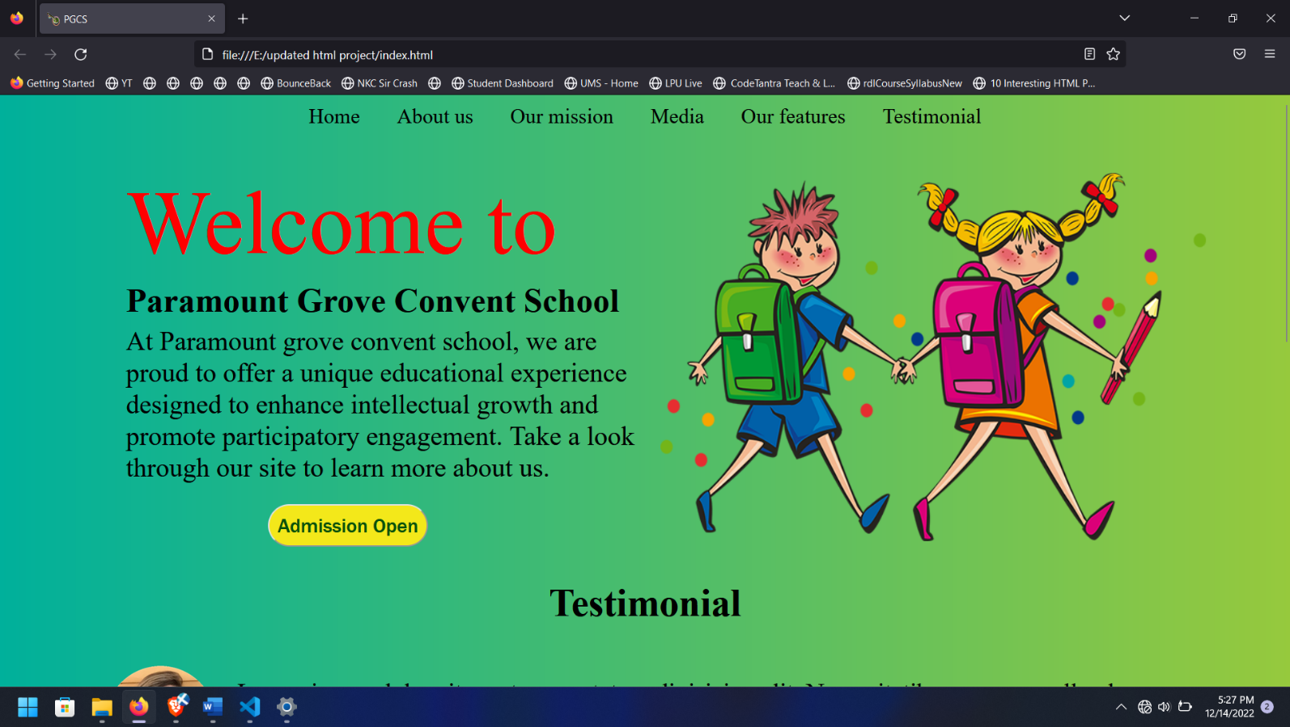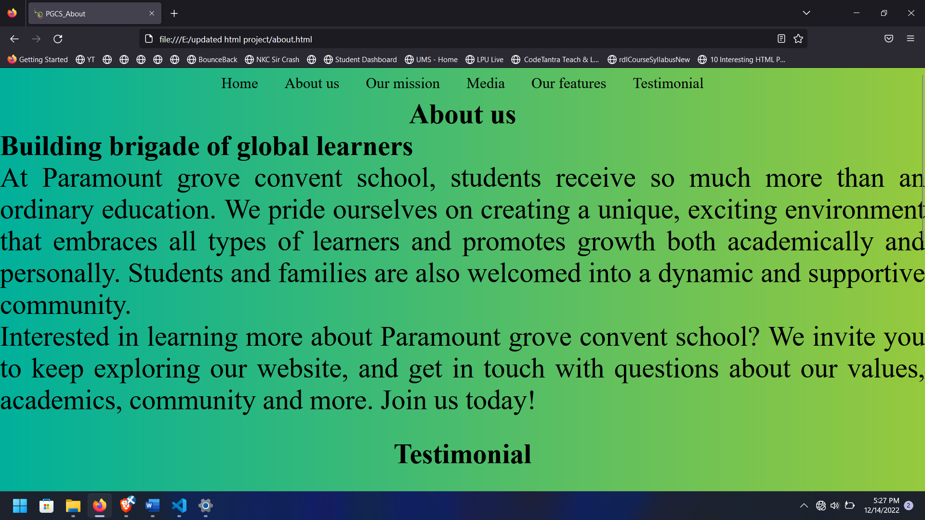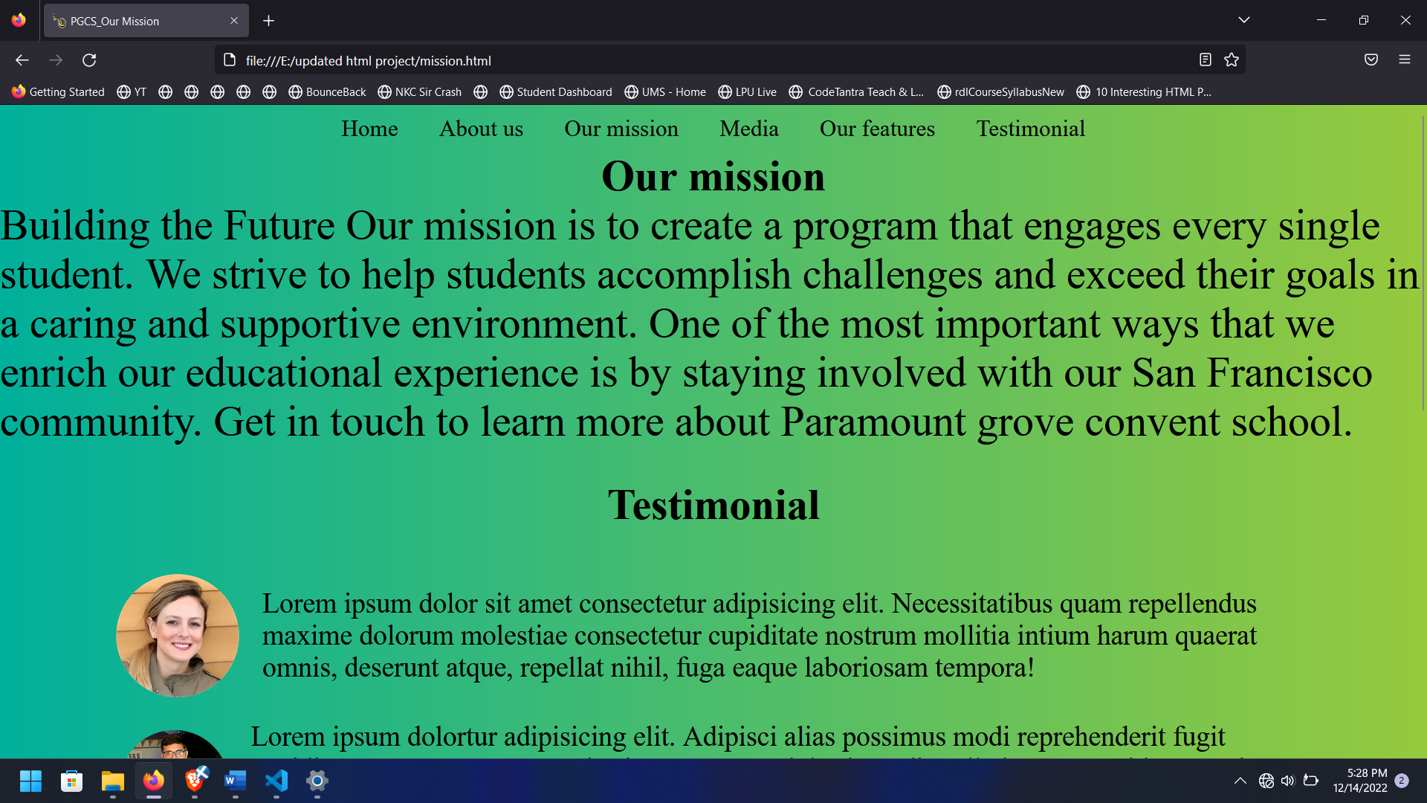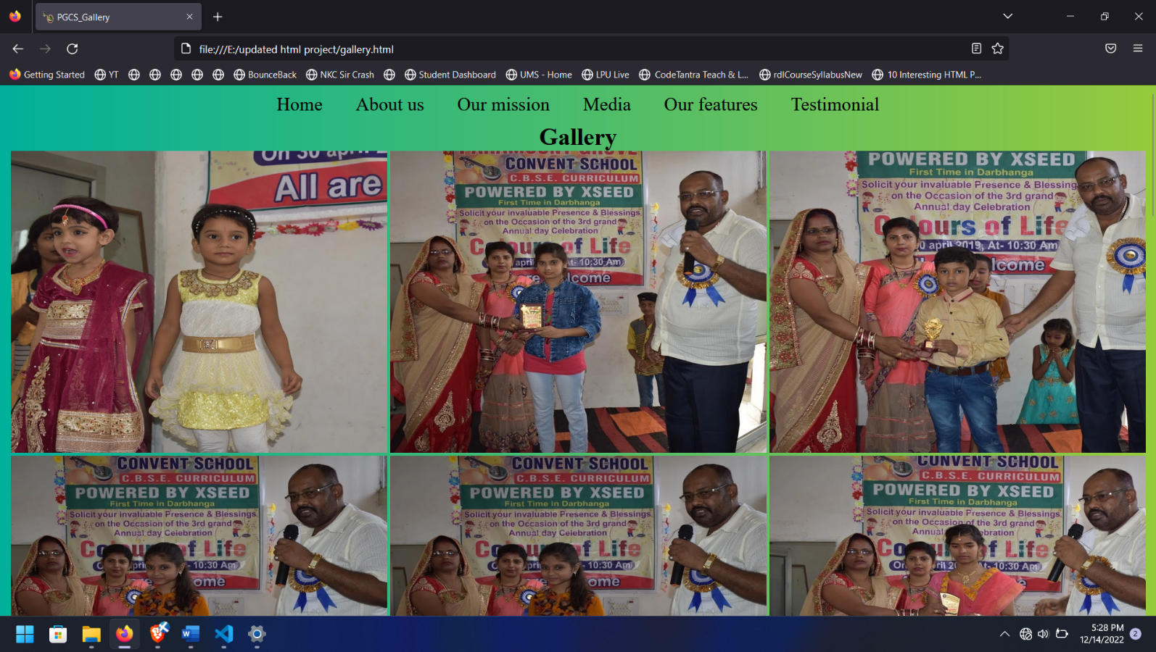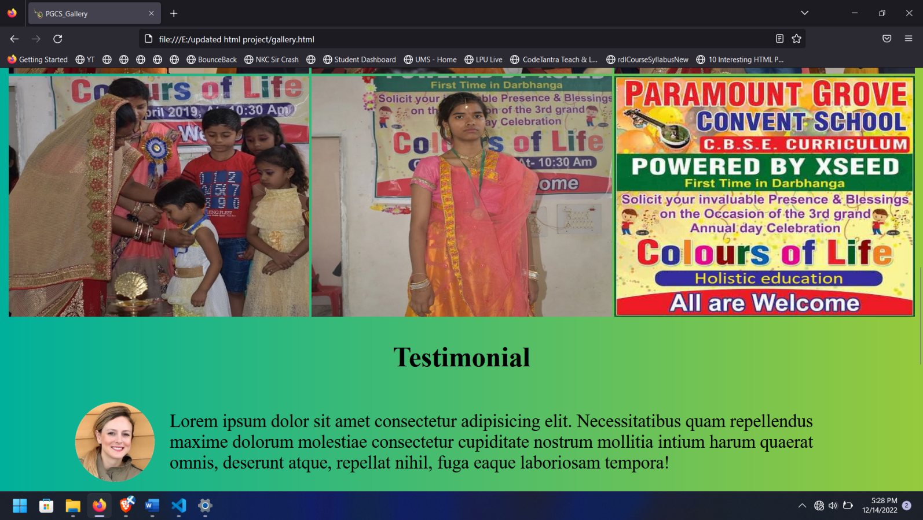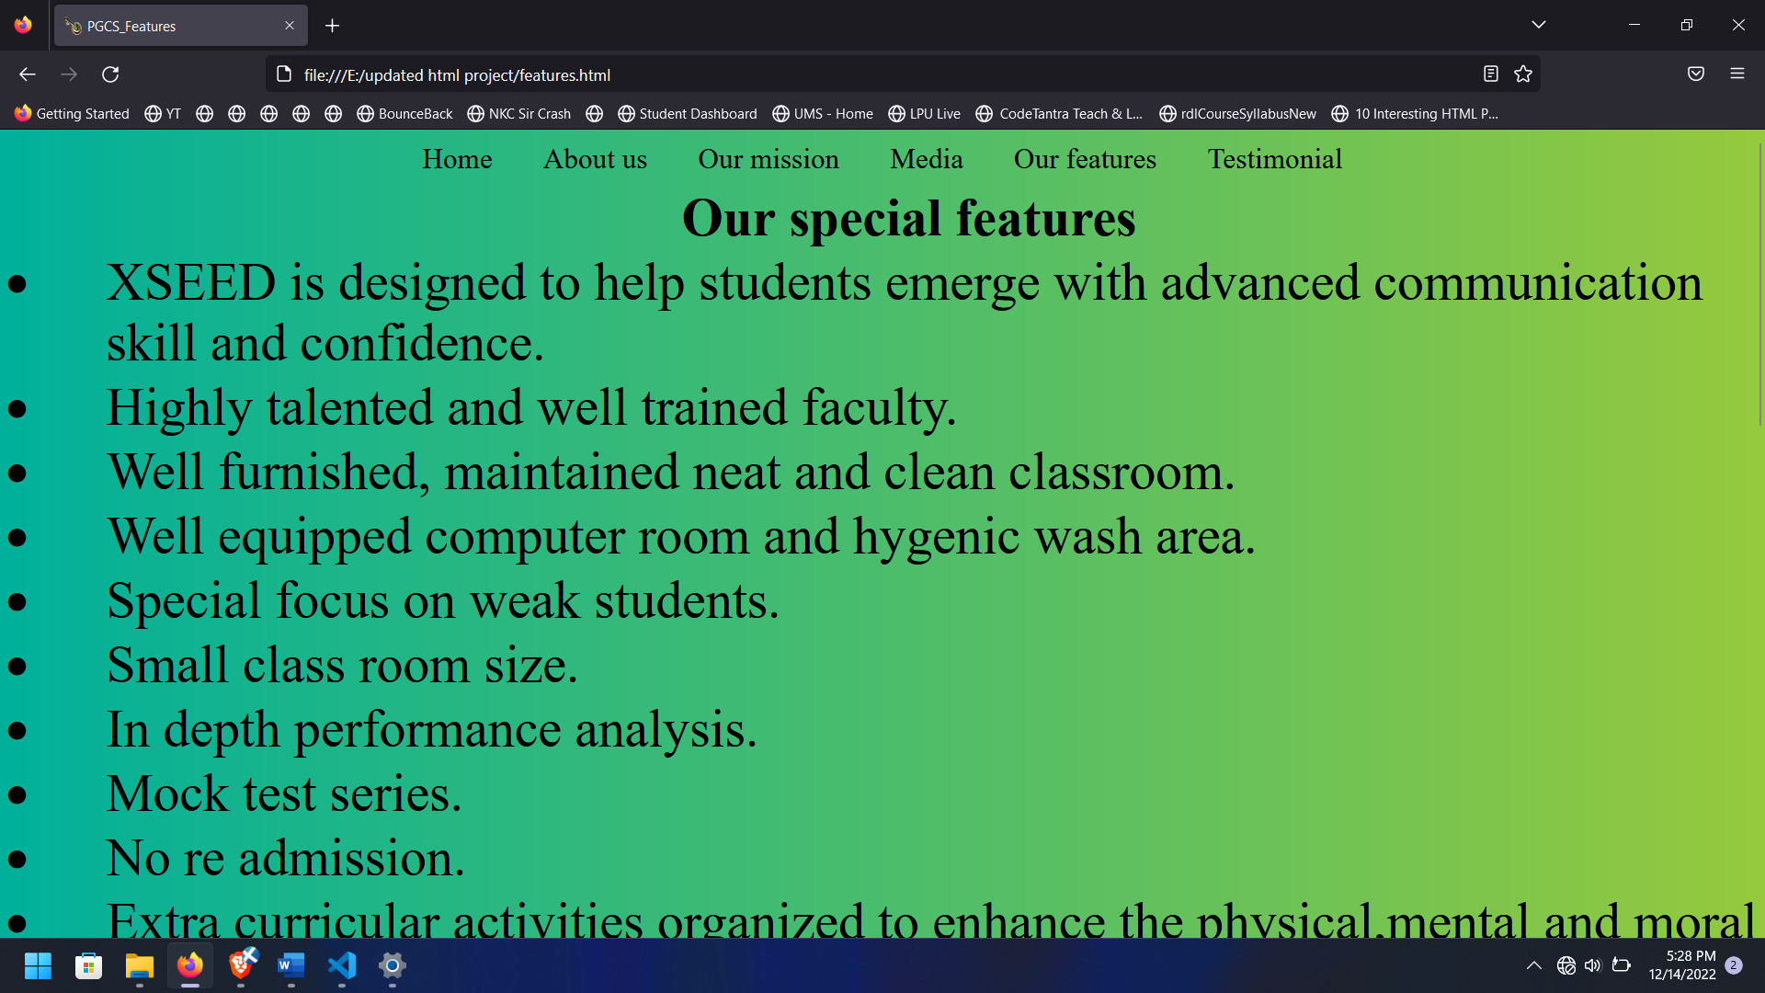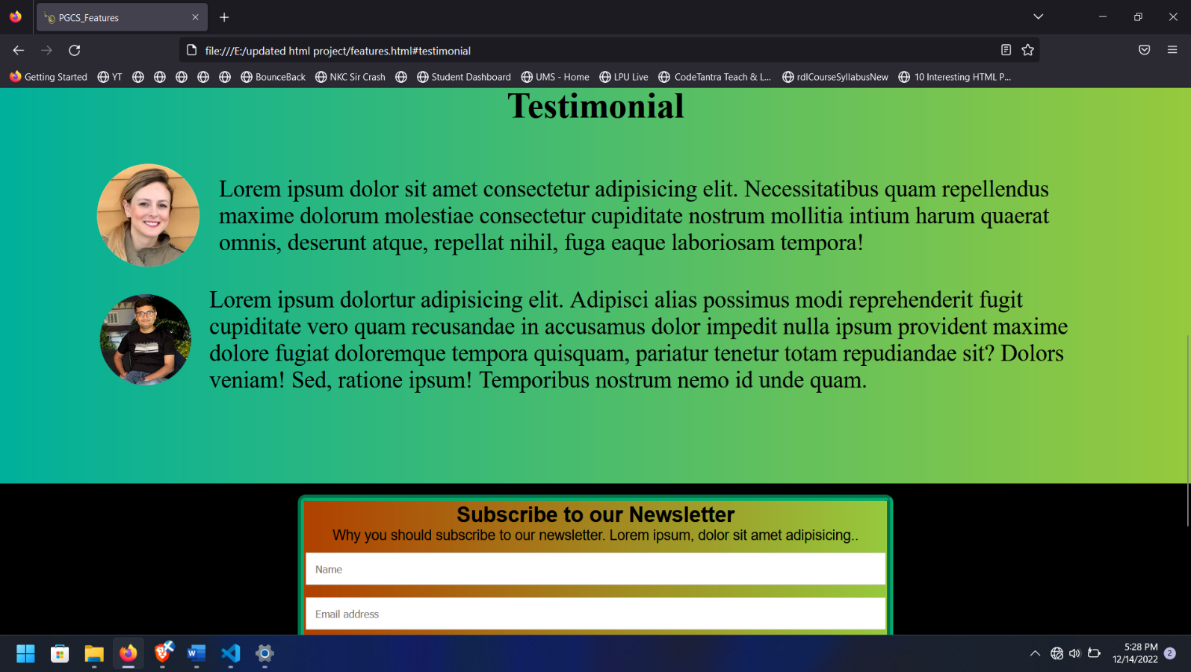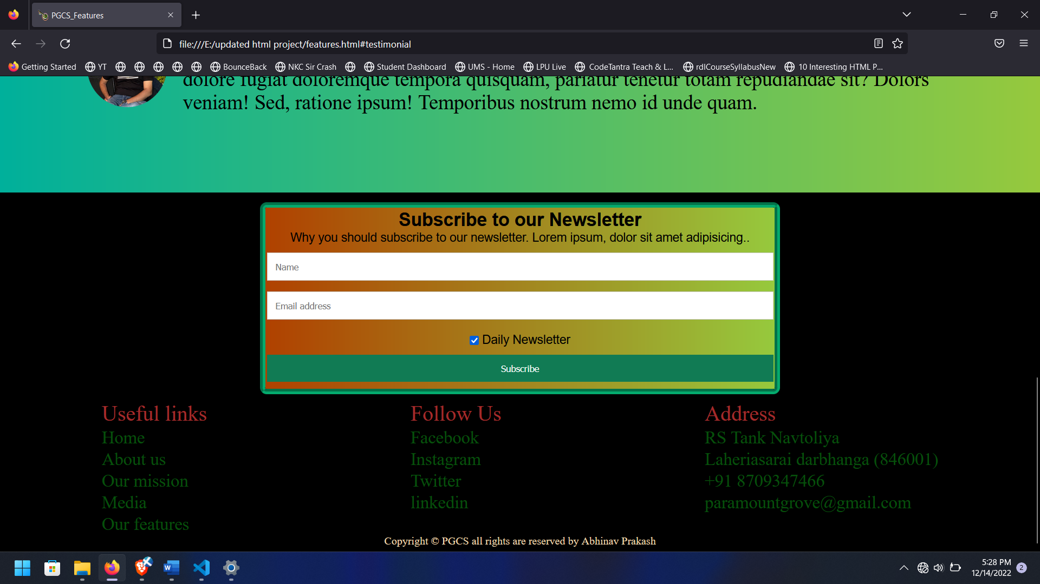

**6. Codes**

**Index page**

<!DOCTYPE html>

<html lang=”en”>

<head>

    <meta charset=”UTF-8”>

    <meta http-equiv=”X-UA-Compatible” content=”IE=edge”>

    <meta name=”viewport” content=”width=device-width, initial-scale=1.0”>

    <link rel=”stylesheet” href=”styles.css”>

    <link rel=”icon” href=”school logo.png” type=”image/x-icon”>

    <link rel=”stylesheet” href=”footer.css”>

    <title>PGCS</title>

</head>

<body>

    <div id=”navbar”>

        <ul>

            <li><a href=”index.html”> Home </a></li>

            <li><a href=”about.html”>About us</a></li>

            <li><a href=”mission.html”> Our mission</a></li>

            <li><a href=”gallery.html”>Media</a></li>

            <li><a href=”features.html”> Our features</a></li>

            <li><a href=”#testimonial”>Testimonial</a></li>

        </ul>

    </div>

    <div class=”upperbgi”>

        <section class=”container”>

            <div class=”herobox”>

                <div class=”left”>

                    <p class=”welcome”>Welcome to</p>

                    <h1 class=”pgcs”>Paramount Grove Convent School</h1>

                    <p class=”msg”>At Paramount grove convent school, we are proud to offer a unique educational

                        experience designed to enhance intellectual growth and promote participatory engagement. Take a

                        look through our site to learn more about us.</p>

                    <button class=”btn1”> <a href=”admission.html”>Admission Open</a></button>

                </div>

                <div class=”right”>

                    <img src=”hero.png” alt=”header images” class=”right img”>

                </div>

            </div>

        </section>

        <!-- **************************testimonial******************* 🡪

        <section id=”testimonial”>

            <div class=”test1”>

                <h1>Testimonial</h1>

            </div>

            <div class=”test2”>

                <img src=”test.png” height=”150px” width=”250px” alt=”testpng”>

                <p>Lorem ipsum dolor sit amet consectetur adipisicing elit. Necessitatibus quam repellendus maxime

                    dolorum molestiae consectetur cupiditate nostrum mollitia intium harum quaerat omnis, deserunt

                    atque, repellat nihil, fuga eaque laboriosam tempora!</p>

            </div>

            <div class=”test2”>

                <img class=”img” src=”13.png” height=”170px” width=”270px” alt=”testpng”>

                <p>Lorem ipsum dolortur adipisicing elit. Adipisci alias possimus modi reprehenderit fugit cupiditate

                    vero quam recusandae in accusamus dolor impedit nulla ipsum provident maxime dolore fugiat

                    doloremque tempora quisquam, pariatur tenetur totam repudiandae sit? Dolors veniam! Sed, ratione

                    ipsum! Temporibus nostrum nemo id unde quam.</p>

            </div>

        </section>

    </div>

    </div>

    <!-- ************newsletter********************************* 🡪

    <div class=”outerfooter”>

        <div id=”newsletter”>

            <form action=”/action_page.php”>

                <div class=”newsletter”>

                    <h2>Subscribe to our Newsletter</h2>

                    <p>Why you should subscribe to our newsletter. Lorem ipsum, dolor sit amet adipisicing..</p>

                </div>

                <div class=”newsletter” style=”background-color:rgb(170, 248, 174)”>

                    <input type=”text” placeholder=”Name” name=”name” required>

                    <input type=”text” placeholder=”Email address” name=”mail” required>

                    <label>

                        <input type=”checkbox” checked=”checked” name=”subscribe”> Daily Newsletter

                    </label>

                </div>

                <div class=”newsletter”>

                    <input type=”submit” value=”Subscribe”>

                </div>

            </form>

        </div>

        <!-- ********************footerarea******************* 🡪

        <div class=”footerarea”>

            <div class=”fp1”>

                <p class=”pfp”>Useful links </p>

                <div id=”footernavbar”>

                    <ul>

                        <li><a href=”index.html”> Home </a></li>

                        <li><a href=”about.html”>About us</a></li>

                        <li><a href=”mission.html”> Our mission</a></li>

                        <li><a href=”gallery.html”>Media</a></li>

                        <li><a href=”features.html”> Our features</a></li>

                    </ul>

                </div>

            </div>

            <div class=”address1”>

                <p class=”pfollowus”>Follow Us

                </p>

                <div id=”followus”>

                    <ul>

                        <li><a href=”https://www.facebook.com”> Facebook </a></li>

                        <li><a href=”https://www.instagram.com”>Instagram</a></li>

                        <li><a href=”https://twitter.com”> Twitter</a></li>

                        <li><a href=”https://linkedin.com”>linkedin</a></li>

                    </ul>

                </div>

            </div>

            <div class=”address1”>

                <p class=”paddress”>Address</p>

                <div id=”address”>

                    <ul>

                        <li><a href=”https://www.google.com/maps/place/Paramount+grove+convent+school/@26.1191615,85.9058748,17z/data=!3m1!4b1!4m5!3m4!1s0x39edb8f37cc981ff:0xd306e75e9fea102!8m2!3d26.1191626!4d85.9080535”>RS Tank Navtoliya </a></li>

                        <li><a href=”https://www.google.com/maps/place/Paramount+grove+convent+school/@26.1191615,85.9058748,17z/data=!3m1!4b1!4m5!3m4!1s0x39edb8f37cc981ff:0xd306e75e9fea102!8m2!3d26.1191626!4d85.9080535”>Laheriasarai arbhanga (846001) </a></li>

                        <li><a href=”tel:91 8709347466”>+91 8709347466</a></li>

                        <li><a href=”mailto:paramountgrove@gmail.com”>[paramountgrove@gmail.com</a></li](mailto:paramountgrove@gmail.com%3c/a%3e%3c/li)>

                    </ul>

                </div>

            </div>

        </div>

    </div>

    <footer>

        Copyright &copy PGCS all rights are reserved by Abhinav Prakash</footer>

</body>

</html>

**About page**

<!DOCTYPE html>

<html lang="en">

<head>

    <meta charset="UTF-8">

    <meta http-equiv="X-UA-Compatible" content="IE=edge">

    <meta name="viewport" content="width=device-width, initial-scale=1.0">

    <link rel="stylesheet" href="styles.css">

    <link rel="icon" href="school logo.png" type="image/x-icon">

    <title>PGCS_About</title>

</head>

<body>

    <div id="navbar">

        <ul>

            <li><a href="index.html"> Home  </a></li>

            <li><a href="about.html">About us</a></li>

            <li><a href="mission.html"> Our mission</a></li>

            <li><a href="gallery.html">Media</a></li>

            <li><a href="features.html"> Our features</a></li>

            <li><a href="#testimonial">Testimonial</a></li>

        </ul>

    </div>

<div class="upperbgi">

    <div id="aboutus">

        <h1>About us</h1>

        <b>Building brigade of global learners</b>

        <br>

At Paramount grove convent school, students receive so much more than an ordinary education. We pride ourselves on creating a unique, exciting environment that embraces all types of learners and promotes growth both academically and personally. Students and families are also welcomed into a dynamic and supportive community.

<br>

Interested in learning more about Paramount grove convent school? We invite you to keep exploring our website, and get in touch with questions about our values, academics, community and more. Join us today!

</div>

<br><br>

<section id="testimonial">

    <div class="test1">

        <h1>Testimonial</h1>

    </div>

    <div class="test2">

        <img src="test.png" height="150px" width="250px" alt="testpng">

        <p>Lorem ipsum dolor sit amet consectetur adipisicing elit. Necessitatibus quam repellendus maxime dolorum molestiae consectetur cupiditate nostrum mollitia intium harum quaerat omnis, deserunt atque, repellat nihil, fuga eaque laboriosam tempora!</p>

    </div>

    <div class="test2">

        <img class="img" src="13.png" height="170px" width="270px" alt="testpng">

        <p>Lorem ipsum dolortur adipisicing elit. Adipisci alias possimus modi reprehenderit fugit cupiditate vero quam recusandae in accusamus dolor impedit nulla ipsum provident maxime dolore fugiat doloremque tempora quisquam, pariatur tenetur totam repudiandae sit? Dolors veniam! Sed, ratione ipsum! Temporibus nostrum nemo id unde quam.</p>

    </div>

</section>

</div>

<!-- *******************************************************newsletter************************************************************************* -->

<div class="outerfooter">

    <div id="newsletter">

<form action="/action_page.php">

  <div class="newsletter">

    <h2>Subscribe to our Newsletter</h2>

    <p>Why you should subscribe to our newsletter. Lorem ipsum, dolor sit amet adipisicing..</p>

  </div>

  <div class="newsletter" style="background-color:rgb(170, 248, 174)">

    <input type="text" placeholder="Name" name="name" required>

    <input type="text" placeholder="Email address" name="mail" required>

    <label>

      <input type="checkbox" checked="checked" name="subscribe"> Daily Newsletter

    </label>

  </div>

  <div class="newsletter">

    <input type="submit" value="Subscribe">

  </div>

</form>

    </div>

    <!-- *******************************************************footer area************************************************** -->

<div class="footerarea">

    <div class="fp1"><p class="pfp">Useful links </p>

        <div id="footernavbar">

            <ul>

                <li><a href="index.html"> Home  </a></li>

                <li><a href="about.html">About us</a></li>

                <li><a href="mission.html"> Our mission</a></li>

                <li><a href="gallery.html">Media</a></li>

                <li><a href="features.html"> Our features</a></li>

            </ul>

        </div>

    </div>

    <div class="address1">

        <p class="pfollowus">Follow Us

        </p>

        <div id="followus"> <ul>

            <li><a href="https://www.facebook.com"> Facebook  </a></li>

            <li><a href="https://www.instagram.com">Instagram</a></li>

            <li><a href="https://twitter.com"> Twitter</a></li>

            <li><a href="https://linkedin.com">linkedin</a></li>

        </ul>

    </div>

    </div>

    <div class="address1">

        <p class="paddress">Address</p>

        <div id="address">    <ul>

            <li><a href="https://www.google.com/maps/place/Paramount+grove+convent+school/@26.1191615,85.9058748,17z/data=!3m1!4b1!4m5!3m4!1s0x39edb8f37cc981ff:0xd306e75e9fea102!8m2!3d26.1191626!4d85.9080535">RS Tank Navtoliya </a></li>

            <li><a href="https://www.google.com/maps/place/Paramount+grove+convent+school/@26.1191615,85.9058748,17z/data=!3m1!4b1!4m5!3m4!1s0x39edb8f37cc981ff:0xd306e75e9fea102!8m2!3d26.1191626!4d85.9080535">Laheriasarai darbhanga (846001) </a></li>

            <li><a href="tel:91 8709347466">+91 8709347466</a></li>

            <li><a href="mailto:paramountgrove@gmail.com">paramountgrove@gmail.com</a></li>

            </ul>

        </div>

    </div>

</div>

</div>

<footer>

    Copyright &copy PGCS all rights are reserved by Abhinav Prakash</footer>

</body>

</html>

**Our mission**

<!DOCTYPE html>

<html lang="en">

<head>

    <meta charset="UTF-8">

    <meta http-equiv="X-UA-Compatible" content="IE=edge">

    <meta name="viewport" content="width=device-width, initial-scale=1.0">

    <link rel="stylesheet" href="styles.css">

    <link rel="icon" href="school logo.png" type="image/x-icon">

    <title>PGCS_Our Mission</title>

</head>

<body>

    <div id="navbar">

        <ul>

            <li><a href="index.html"> Home  </a></li>

            <li><a href="about.html">About us</a></li>

            <li><a href="mission.html"> Our mission</a></li>

            <li><a href="gallery.html">Media</a></li>

            <li><a href="features.html"> Our features</a></li>

            <li><a href="#testimonial">Testimonial</a></li>

        </ul>

    </div>

<div class="upperbgi">

<div id="ourmission">

    <h1>Our mission </h1>

    <p>Building the Future

        Our mission is to create a program that engages every single student. We strive to help students accomplish challenges and exceed their goals in a caring and supportive environment. One of the most important ways that we enrich our educational experience is by staying involved with our San Francisco community. Get in touch to learn more about Paramount grove convent school.</p>

</div>

<br><br>

<section id="testimonial">

    <div class="test1">

        <h1>Testimonial</h1>

    </div>

    <div class="test2">

        <img src="test.png" height="150px" width="250px" alt="testpng">

        <p>Lorem ipsum dolor sit amet consectetur adipisicing elit. Necessitatibus quam repellendus maxime dolorum molestiae consectetur cupiditate nostrum mollitia intium harum quaerat omnis, deserunt atque, repellat nihil, fuga eaque laboriosam tempora!</p>

    </div>

    <div class="test2">

        <img class="img" src="13.png" height="170px" width="270px" alt="testpng">

        <p>Lorem ipsum dolortur adipisicing elit. Adipisci alias possimus modi reprehenderit fugit cupiditate vero quam recusandae in accusamus dolor impedit nulla ipsum provident maxime dolore fugiat doloremque tempora quisquam, pariatur tenetur totam repudiandae sit? Dolors veniam! Sed, ratione ipsum! Temporibus nostrum nemo id unde quam.</p>

    </div>

</section>

</div>

<!-- *******************************************************newsletter************************************************************************* -->

<div class="outerfooter">

    <div id="newsletter">

<form action="/action_page.php">

  <div class="newsletter">

    <h2>Subscribe to our Newsletter</h2>

    <p>Why you should subscribe to our newsletter. Lorem ipsum, dolor sit amet adipisicing..</p>

  </div>

  <div class="newsletter" style="background-color:rgb(170, 248, 174)">

    <input type="text" placeholder="Name" name="name" required>

    <input type="text" placeholder="Email address" name="mail" required>

    <label>

      <input type="checkbox" checked="checked" name="subscribe"> Daily Newsletter

    </label>

  </div>

  <div class="newsletter">

    <input type="submit" value="Subscribe">

  </div>

</form>

    </div>

    <!-- *******************************************************footer area************************************************** -->

<div class="footerarea">

    <div class="fp1"><p class="pfp">Useful links </p>

        <div id="footernavbar">

            <ul>

                <li><a href="index.html"> Home  </a></li>

                <li><a href="about.html">About us</a></li>

                <li><a href="mission.html"> Our mission</a></li>

                <li><a href="gallery.html">Media</a></li>

                <li><a href="features.html"> Our features</a></li>

            </ul>

        </div>

    </div>

    <div class="address1">

        <p class="pfollowus">Follow Us

        </p>

        <div id="followus"> <ul>

            <li><a href="https://www.facebook.com"> Facebook  </a></li>

            <li><a href="https://www.instagram.com">Instagram</a></li>

            <li><a href="https://twitter.com"> Twitter</a></li>

            <li><a href="https://linkedin.com">linkedin</a></li>

        </ul>

    </div>

    </div>

    <div class="address1">

        <p class="paddress">Address</p>

        <div id="address">    <ul>

            <li><a href="https://www.google.com/maps/place/Paramount+grove+convent+school/@26.1191615,85.9058748,17z/data=!3m1!4b1!4m5!3m4!1s0x39edb8f37cc981ff:0xd306e75e9fea102!8m2!3d26.1191626!4d85.9080535">RS Tank Navtoliya </a></li>

            <li><a href="https://www.google.com/maps/place/Paramount+grove+convent+school/@26.1191615,85.9058748,17z/data=!3m1!4b1!4m5!3m4!1s0x39edb8f37cc981ff:0xd306e75e9fea102!8m2!3d26.1191626!4d85.9080535">Laheriasarai darbhanga (846001) </a></li>

            <li><a href="tel:91 8709347466">+91 8709347466</a></li>

            <li><a href="mailto:paramountgrove@gmail.com">paramountgrove@gmail.com</a></li>

            </ul>

        </div>

    </div>

</div>

</div>

<footer>

    Copyright &copy PGCS all rights are reserved by Abhinav Prakash</footer>

</body>

</html>

**Media**

<!DOCTYPE html>

<html lang="en">

<head>

    <meta charset="UTF-8">

    <meta http-equiv="X-UA-Compatible" content="IE=edge">

    <meta name="viewport" content="width=device-width, initial-scale=1.0">

    <link rel="stylesheet" href="styles.css">

    <link rel="icon" href="school logo.png" type="image/x-icon">

    <title>PGCS_Gallery</title>

</head>

<body>

    <div id="navbar">

        <ul>

            <li><a href="index.html"> Home  </a></li>

            <li><a href="about.html">About us</a></li>

            <li><a href="mission.html"> Our mission</a></li>

            <li><a href="gallery.html">Media</a></li>

            <li><a href="features.html"> Our features</a></li>

            <li><a href="#testimonial">Testimonial</a></li>

        </ul>

    </div>

<div class="upperbgi">

    <div id="gallery"><h1>Gallery</h1>

        <img src="DSC_0103.JPG" height="400px" width="500px" alt="photo1"> <img src="DSC_0172.JPG" height="400px" width="500px" alt="photo3"> <img src="DSC_0166.JPG.jpg" height="400px" width="500px" alt="photo2"> <img src="DSC_0175 (1).JPG" height="400px" width="500px"alt="photo4"> <img src="DSC_0175.JPG" height="400px" width="500px"alt="photo5"> <img src="DSC_0180.JPG" height="400px" width="500px"alt="photo6"> <img src="DSC_0190.JPG" height="400px" width="500px"alt="photo7"> <img src="DSC_0191.JPG" height="400px" width="500px"alt="photo8"> <img src="DSC_0193.JPG" height="400px" width="500px"alt="photo9"> <img src="DSC_0198.JPG" height="400px" width="500px"alt="photo10"> <img src="DSC_0218.JPG" height="400px" width="500px"alt="photo11"> <img src="google.jpg" height="400px"

                width="500px"alt="photo12">

</div>

<br><br>

<section id="testimonial">

    <div class="test1">

        <h1>Testimonial</h1>

    </div>

    <div class="test2">

        <img src="test.png" height="150px" width="250px" alt="testpng">

        <p>Lorem ipsum dolor sit amet consectetur adipisicing elit. Necessitatibus quam repellendus maxime dolorum molestiae consectetur cupiditate nostrum mollitia intium harum quaerat omnis, deserunt atque, repellat nihil, fuga eaque laboriosam tempora!</p>

    </div>

    <div class="test2">

        <img class="img" src="13.png" height="170px" width="270px" alt="testpng">

        <p>Lorem ipsum dolortur adipisicing elit. Adipisci alias possimus modi reprehenderit fugit cupiditate vero quam recusandae in accusamus dolor impedit nulla ipsum provident maxime dolore fugiat doloremque tempora quisquam, pariatur tenetur totam repudiandae sit? Dolors veniam! Sed, ratione ipsum! Temporibus nostrum nemo id unde quam.</p>

    </div>

</section>

<hr>

</div>

<!-- ************newsletter***************************** -->

<div class="outerfooter">

    <div id="newsletter">

<form action="/action_page.php">

  <div class="newsletter">

    <h2>Subscribe to our Newsletter</h2>

    <p>Why you should subscribe to our newsletter. Lorem ipsum, dolor sit amet adipisicing..</p>

  </div>

  <div class="newsletter" style="background-color:rgb(170, 248, 174)">

    <input type="text" placeholder="Name" name="name" required>

    <input type="text" placeholder="Email address" name="mail" required>

    <label>

      <input type="checkbox" checked="checked" name="subscribe"> Daily Newsletter

    </label>

  </div>

  <div class="newsletter">

    <input type="submit" value="Subscribe">

  </div>

</form>

    </div>

    <!-- *******************************************************footer area************************************************** -->

<div class="footerarea">

    <div class="fp1"><p class="pfp">Useful links </p>

        <div id="footernavbar">

            <ul>

                <li><a href="index.html"> Home  </a></li>

                <li><a href="about.html">About us</a></li>

                <li><a href="mission.html"> Our mission</a></li>

                <li><a href="gallery.html">Media</a></li>

                <li><a href="features.html"> Our features</a></li>

            </ul>

        </div>

    </div>

    <div class="address1">

        <p class="pfollowus">Follow Us

        </p>

        <div id="followus"> <ul>

            <li><a href="https://www.facebook.com"> Facebook  </a></li>

            <li><a href="https://www.instagram.com">Instagram</a></li>

            <li><a href="https://twitter.com"> Twitter</a></li>

            <li><a href="https://linkedin.com">linkedin</a></li>

        </ul>

    </div>

    </div>

    <div class="address1">

        <p class="paddress">Address</p>

        <div id="address">    <ul>

            <li><a href="https://www.google.com/maps/place/Paramount+grove+convent+school/@26.1191615,85.9058748,17z/data=!3m1!4b1!4m5!3m4!1s0x39edb8f37cc981ff:0xd306e75e9fea102!8m2!3d26.1191626!4d85.9080535">RS Tank Navtoliya </a></li>

            <li><a href="https://www.google.com/maps/place/Paramount+grove+convent+school/@26.1191615,85.9058748,17z/data=!3m1!4b1!4m5!3m4!1s0x39edb8f37cc981ff:0xd306e75e9fea102!8m2!3d26.1191626!4d85.9080535">Laheriasarai darbhanga (846001) </a></li>

            <li><a href="tel:91 8709347466">+91 8709347466</a></li>

            <li><a href="mailto:paramountgrove@gmail.com">paramountgrove@gmail.com</a></li>

            </ul>

        </div>

    </div>

</div>

</div>

<footer>

    Copyright &copy PGCS all rights are reserved by Abhinav Prakash</footer>

</body>

</html>

**Features**

<!DOCTYPE html>

<html lang="en">

<head>

    <meta charset="UTF-8">

    <meta http-equiv="X-UA-Compatible" content="IE=edge">

    <meta name="viewport" content="width=device-width, initial-scale=1.0">

    <link rel="stylesheet" href="styles.css">

    <link rel="icon" href="school logo.png" type="image/x-icon">

    <title>PGCS_Features</title>

    </head>

<body>

    <div class="upperbgi">

    <div id="navbar">

        <ul>

            <li><a href="index.html"> Home  </a></li>

            <li><a href="about.html">About us</a></li>

            <li><a href="mission.html"> Our mission</a></li>

            <li><a href="gallery.html">Media</a></li>

            <li><a href="features.html"> Our features</a></li>

            <li><a href="#testimonial">Testimonial</a></li>

        </ul>

    </div>

    <div id="features"><h1>Our special features</h1>

        <ul style="list-style-type: disc;">

            <li>XSEED is designed to help students emerge with advanced communication skill and confidence.</li>

            <li>Highly talented and well trained faculty.</li>

            <li>Well furnished, maintained neat and clean classroom.</li>

            <li>Well equipped computer room and hygenic wash area.</li>

            <li>Special focus on weak students.</li>

            <li>Small class room size.</li>

            <li>In depth performance analysis.</li>

            <li>Mock test series.</li>

            <li>No re admission.</li>

            <li>Extra curricular activities organized to enhance the physical,mental and moral skill of the child through yoga and indoor games.​</li>

        </ul>

    </div>

    <br><br>

        <section id="testimonial">

        <div class="test1">

            <h1>Testimonial</h1>

        </div>

        <div class="test2">

            <img src="test.png" height="150px" width="250px" alt="testpng">

            <p>Lorem ipsum dolor sit amet consectetur adipisicing elit. Necessitatibus quam repellendus maxime dolorum molestiae consectetur cupiditate nostrum mollitia intium harum quaerat omnis, deserunt atque, repellat nihil, fuga eaque laboriosam tempora!</p>

        </div>

        <div class="test2">

            <img class="img" src="13.png" height="170px" width="270px" alt="testpng">

            <p>Lorem ipsum dolortur adipisicing elit. Adipisci alias possimus modi reprehenderit fugit cupiditate vero quam recusandae in accusamus dolor impedit nulla ipsum provident maxime dolore fugiat doloremque tempora quisquam, pariatur tenetur totam repudiandae sit? Dolors veniam! Sed, ratione ipsum! Temporibus nostrum nemo id unde quam.</p>

        </div>

    </section>

    </div>

<!--*******************newsletter******************************** -->

<div class="outerfooter">

    <div id="newsletter">

<form action="/action_page.php">

  <div class="newsletter">

    <h2>Subscribe to our Newsletter</h2>

    <p>Why you should subscribe to our newsletter. Lorem ipsum, dolor sit amet adipisicing..</p>

  </div>

  <div class="newsletter" style="background-color:rgb(170, 248, 174)">

    <input type="text" placeholder="Name" name="name" required>

    <input type="text" placeholder="Email address" name="mail" required>

    <label>

      <input type="checkbox" checked="checked" name="subscribe"> Daily Newsletter

    </label>

  </div>

  <div class="newsletter">

    <input type="submit" value="Subscribe">

  </div>

</form>

     <!-- **********************footer area************************ -->

<div class="footerarea">

    <div class="fp1"><p class="pfp">Useful links </p>

        <div id="footernavbar">

            <ul>

                <li><a href="index.html"> Home  </a></li>

                <li><a href="about.html">About us</a></li>

                <li><a href="mission.html"> Our mission</a></li>

                <li><a href="gallery.html">Media</a></li>

                <li><a href="features.html"> Our features</a></li>

            </ul>

        </div>

    </div>

    <div class="address1">

        <p class="pfollowus">Follow Us

        </p>

        <div id="followus"> <ul>

            <li><a href="https://www.facebook.com"> Facebook  </a></li>

            <li><a href="https://www.instagram.com">Instagram</a></li>

            <li><a href="https://twitter.com"> Twitter</a></li>

            <li><a href="https://linkedin.com">linkedin</a></li>

        </ul>

    </div>

    </div>

    <div class="address1">

        <p class="paddress">Address</p>

        <div id="address">    <ul>

            <li><a href="https://www.google.com/maps/place/Paramount+grove+convent+school/@26.1191615,85.9058748,17z/data=!3m1!4b1!4m5!3m4!1s0x39edb8f37cc981ff:0xd306e75e9fea102!8m2!3d26.1191626!4d85.9080535">RS Tank Navtoliya </a></li>

            <li><a href="https://www.google.com/maps/place/Paramount+grove+convent+school/@26.1191615,85.9058748,17z/data=!3m1!4b1!4m5!3m4!1s0x39edb8f37cc981ff:0xd306e75e9fea102!8m2!3d26.1191626!4d85.9080535">Laheriasarai darbhanga (846001) </a></li>

            <li><a href="tel:91 8709347466">+91 8709347466</a></li>

            <li><a href="mailto:paramountgrove@gmail.com">paramountgrove@gmail.com</a></li>

            </ul>

        </div>

    </div>

</div>

</div>

<footer>

    Copyright &copy PGCS all rights are reserved by Abhinav Prakash</footer>

</body>

</html>

**CSS**

*{

    margin: 0;padding: 0;

}

a:hover{

    text-underline-offset:auto ;

}

.upperbgi{

    background-image:linear-gradient(to right, #00b09b, #96c93d);

}

#navbar {

    background-image:linear-gradient(to right, #00b09b, #96c93d);;

    text-align: center;

    font: size 500px;

    top: 0px;

    z-index: 100;

}

#navbar ul li {

    display: inline-block;

    margin: 10px 20px;

    font: size 15px;

}

#navbar ul li a {

    color: rgb(0, 0, 0);

    text-decoration: none;

    font-size: 25px;

}

#navbar ul li a :hover{

    color: aqua;

}

.logo{

    display: flex;

}

h3{

    background-color: yellow;

    font-size: 3vw;

    text-align: center;

    font-stretch: extra-expanded;

}

#aboutus,#aboutus b{

    font-size: 3vw;

    text-align: justify;

}

#aboutus h1{

    font-size: 3vw;

    text-align: center;

}

#ourmission h1{

    font-size: 3vw;

    text-align: center;

}

#ourmission p{

    font-size: 3vw;

}

#gallery{

    text-align: center;

    font-weight: 300;

}

#features,#features li {

    text-align: left;

    padding-left: 3vw;

    color: black;

    font-size: 3vw;

}

#features h1{

    color:black;

    text-align: center;

    font-size: 3vw;

}

.container{

    min-width: 100vw;

}

.herobox{

    display: flex;

    align-items: center;

    justify-content: space-evenly;

    padding: 40px 100px;

}

.left{

    margin-left: 50px;

    background-color: green,white;

}

.welcome{

    color: red;

    margin-bottom: 8px;

    font-weight: 550;

    font-size: 7vw;

}

.left h1{

    font-size: 40px;

    margin-bottom: 8px;

    line-height: 44px;

}

.msg{

    margin-bottom: 25px;

    font-size: xx-large;

}

.btn1{

    background-color: rgb(243, 232, 26);

    padding:10px ;

    cursor: pointer;

    font-size: 24px;

    border-radius:  40px;

    position: relative;

    left: 11vw;

    font-family: 'Franklin Gothic Medium', 'Arial Narrow', Arial, sans-serif;

}

.btn1 a{

    list-style-type:none;

    text-decoration: none;

    color: rgb(6, 80, 11);

}

.btn1:hover{

    background-color:aqua;

}

/* ****************************testimonial******************************* */

#testimonial{

    display: flex;

    flex-direction: column;

    align-items: center;

    padding: 0 100px;

    padding-bottom: 100px;

    background-color: no color;

}

.test1{

    padding-bottom: 40px;

    font-size: 2vw;

}

.test2{

    display: flex;

    flex-direction: row;

    align-items: center;

    font-size: 30px ;

}

/* ********************footer area ***************************** */

.footerarea{

    border: 2vw;

    border-color: red;

    display: flex;

    list-style: none;

    justify-content: space-around;

    font-size: 26px;

    background-color:black;

}

.fp,.followus,.address{

    font: bold;

    font-size: xx-large

    list-style-type:none;

    text-decoration:none;

}

.pfp,.paddress,.pfollowus{

    font-size: xx-large;

    color: brown;

}

.footerarea ul li a{

    list-style-type:none;

    text-decoration: none;

    color: rgb(6, 80, 11);

}

/* ****************************newsletter*********************** */

form {

    font-family: Arial;

    margin-left: 25vw;

    margin-right: 25vw;

    margin-top:10px ;

    margin-bottom:10px ;

    border-color: #04AA6D;

    border-style: groove;

    border-radius: 10px;

    border-width: 8px;

    background-color: black;

  }

    .newsletter {

    padding: 2px;

    background-image:linear-gradient(to right, #b04100, #96c93d);

    font-size: large;

    text-align: center;

  }

    input[type=text], input[type=submit] {

    width: 100%;

    padding: 12px;

    margin: 8px 0;

    display: inline-block;

    border: 1px solid #ccc;

    box-sizing: border-box;

  }

    input[type=checkbox] {

    margin-top: 16px;

  }

    input[type=submit] {

    background-color: #117b54;

    color: white;

    border: 2px;

  }

    input[type=submit]:hover {

    opacity: 0.8;

  }

  #newsletter{

    padding-top: 4px;

  }

/* *************************footer********************************** */

footer{

    text-align: center;

    background-color:black;

    color: wheat;

    height: 25px;

}

.outerfooter{

    background-color: black;

}

.footerarea ul li a:hover{

    border-bottom: 3px solid #ff7a59;

}

#navbar ul li a:hover{

    border-bottom: 3px solid #ff7a59;

}

**6. Future scope of work**

* I will make my website host in future on google.
* I will work on adding more sections in my web page
* I will improve my design a better lot and will add a lot of customizations in my website.
* Will make partnership with others to understand the working of website more.
* Will work on backend as well in future
* I will add lot more options for live classes, attendance etc

**7. BONAFIDE CERTIFICATE**

Certified that this project report “School Website” is the bonafide work of “ABHINAV PRAKASH, SURYA PRAKASH REDDY, PRABHAT KUMAR SINGH” who carried out the project work under my supervision.

Sushil Lekhi

CSE